Effects of Covid-19 on Global Economies

Daniel Rosini, Gloria Rumao

FE – 541

Fall 2020

**Abstract**

When news broke early in 2020 of a new virus spreading through the Hubei province in China, no one expected a global pandemic that would affect the livelihoods of billions of people from all walks. Most people likely never heard of the name Wuhan, and then it had become one of the most infamous cities in the world, but for all the wrong reasons. Given the integrated global economy that exists today, an event, such as the Coronavirus pandemic, inevitably will make splashes in all economies around the world. The purpose of this study is to examine those ripple effects on the world’s economies and to search for correlations between how a nation was impacted by Covid-19 and how their economies reacted. Additionally, this study will compare how individual states responded to the pandemic and whether their economies reflected these responses.

**Introduction**

The question that this report is attempting to answer is how the impact of coronavirus effect the growth of various global economies. In order to answer this, a variety of the worlds leading stock markets will be examined to see the initial effects of the Coronavirus pandemic on the market, as well growth and recovery proceeding these initial effects. This study will focus on three of the more prominent regions in the global economy: The United States, Europe, and Asia. All three of these regions have been directly impacted by the Coronavirus pandemic and have experienced extensive lockdowns. It is expected that the economies in all three of these regions have taken a massive hit when Covid-19 first emerged, but how did each of these markets react in the proceeding months. Furthermore, was there any correlation between the amount of confirmed Coronavirus cases and the performance of the market.

In addition to the global analysis, this study will look at the United States on a statewide scale. In the early stages of the pandemic, the federal government punted the Coronavirus response to state governments. Since there was not a uniform national response, theCovid-19 infection rates and numbers have varied from state to state. In order to examine how an individual states response affected their economies, the quarterly GDP reports for each state will be examined. The states with the lowest Coronavirus infection rates will be compared to those with the highest rates to see if there is a significant difference in an impact.

**Data and Methods**

1. *Global analysis:*

A variety of data, spanning from global market indices to statewide Covid-19 infections was collected for this analysis. The closing prices for the past 52 weeks for several global stock exchanges was downloaded from the S&P capital platform. These global exchanges included markets from the United States, Europe and Asia. The list of them is as follows:

1. **United States**
2. Dow Jones
3. S & P 500
4. NASDAQ
5. **Europe**
6. Germany DAX
7. Paris CAC 40
8. FTSE 100
9. **Asia**
10. HSI
11. Nikkei255
12. SSE
13. BSE Sensex

The datasets for each of these exchanges were composed of the date and closing prices, as seen below in table 1.

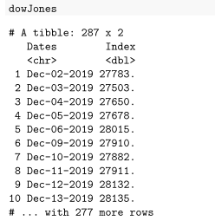

*Table 1: Snapshot of Dow Jones Dataset*

The purpose of these datasets, in terms of project analysis, was to observe the impact of Covid-19 on stock prices over each quarter from Dec 2019 to Nov 2020. The following test hypothesis was formulated to test this:

**H0:** No growth is observed in the stock market daily stock return value.

**H1:** Growth is observed in the stock market daily stock return value.

The graphical representation of the market indexes show a fall in the stock market from the advent of the pandemic. And slow recovery since then. Thus, we get to observe the markets getting back to normal in the 3rd and 4th quarters.  Below is a graph of the Dow Jones industrial average as an example of this trend.

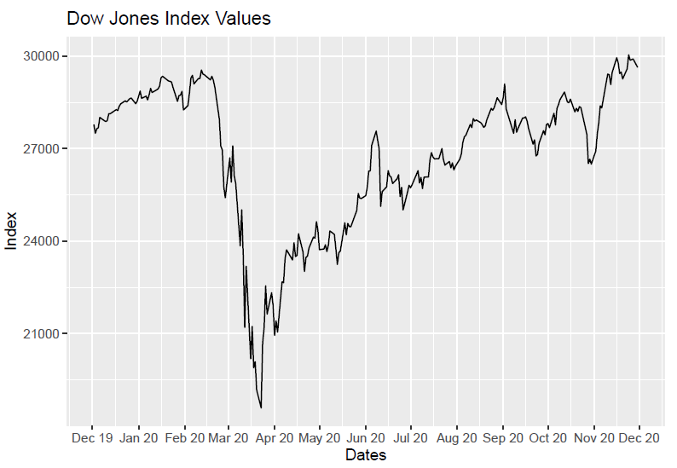

*Figure 1: Plot of Dow Jones Closing Prices*

Before starting with hypothesis testing, we have plotted boxplots to identify if the data has any outliers, and the outliers are being removed.

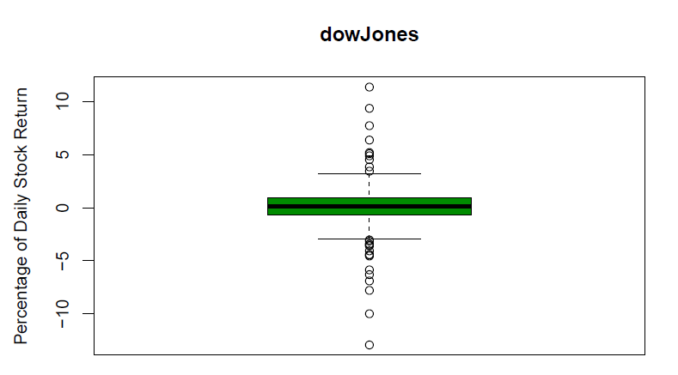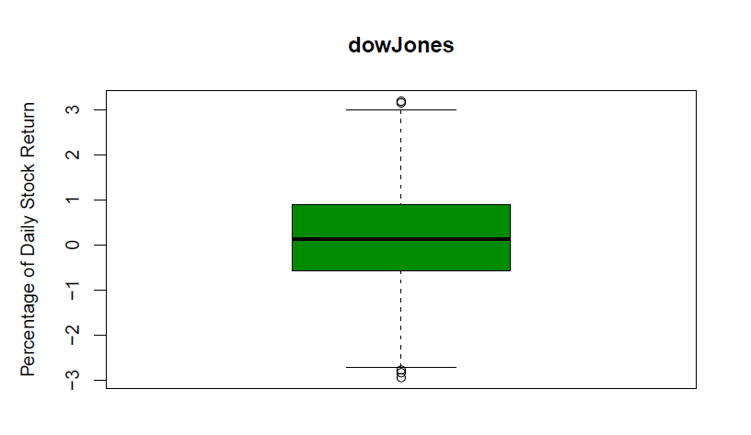

*Figure 2: Boxplots of Dow Jones Dataset*

For Hypothesis testing we have plotted histograms and QQ-plots to check if the data is distributed normally.

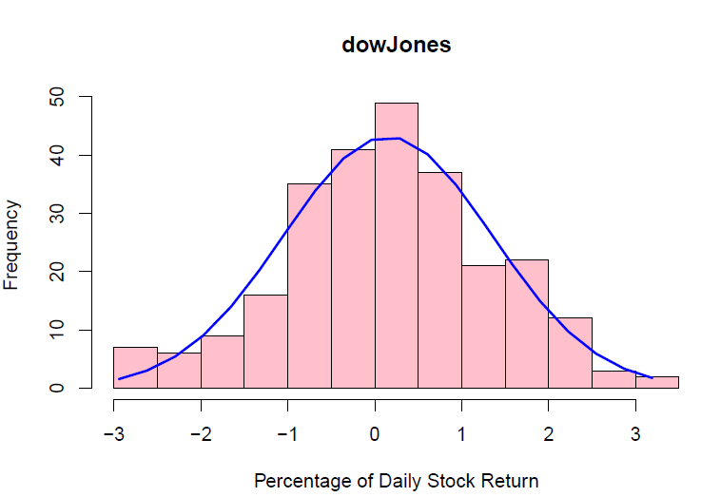 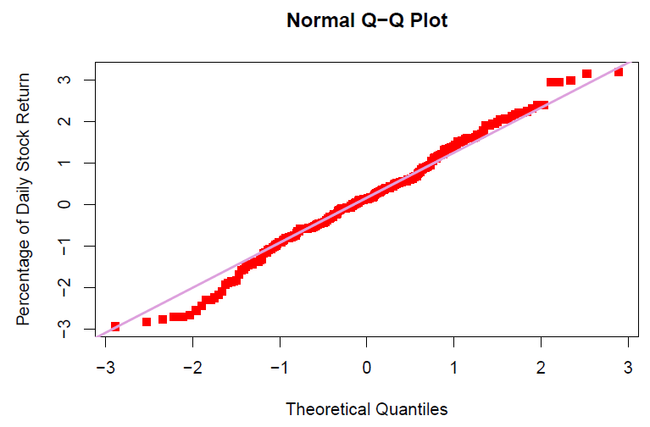

*Figure 3: Histogram and Q-Q Plot of Dow Jones Dataset*

Later we determine the test. Here we use the t-test as the population standard deviation is unknown. The population will be all the stocks on the stock market. And we are using the indices which are calculated using a group of well performing stocks.  Further we go ahead to perform the t-test on different stock indices for different quarters to observe the impact of covid-19.

1. *United States state-wise scale:*

On a statewide scale, data was collected for Covid-19 infections and the quarterly GDP percent change for each state. These data sets were collected from the CDC and BEA respectively, which are both reliable government resources. Unfortunately, the report for the latest quarter, Q3, has not yet been published, therefore the quarterly GDP data was restricted to quarters 1 and 2. A small snapshot of the Covid-19 and GDP datasets can be seen below in table 2 and table 3.

|  |  |  |  |  |  |
| --- | --- | --- | --- | --- | --- |
| Date | state | Total cases | New Cases | Total death | New death |
| 12/3/2020 | AK | 33291 | 760 | 129 | 8 |
| 12/2/2020 | AK | 32531 | 697 | 121 | 0 |
| 12/1/2020 | AK | 31834 | 511 | 121 | 1 |
| 11/30/2020 | AK | 31323 | 507 | 120 | 0 |
| 11/29/2020 | AK | 30816 | 612 | 120 | 0 |
| 11/28/2020 | AK | 30204 | 650 | 120 | 2 |
| 11/27/2020 | AK | 29554 | 662 | 118 | 0 |
| 11/26/2020 | AK | 28892 | 553 | 118 | 3 |

*Table 2: Snapshot of Covid-19 Dataset*

|  |  |  |  |
| --- | --- | --- | --- |
|  | Seasonally adjusted at annual rates | | |
| 2020 | | Rank 2020:Q2 |
| Q1 | Q2 |
| **United States** | **-5.0** | **-31.4** | **.......** |
| **New England** | **-4.8** | **-32.3** | **.......** |
| Connecticut | -6.0 | -31.1 | 23 |
| Maine | -6.5 | -34.4 | 41 |
| Massachusetts | -4.3 | -31.6 | 28 |
| New Hampshire | -2.2 | -36.9 | 45 |
| Rhode Island | -5.2 | -32.4 | 31 |
| Vermont | -5.8 | -38.2 | 47 |

*Table 3: Snapshot of Statewide Quarterly GDP Percent Change Dataset*

The purpose of these data sets, in terms of this projects analysis, was to provide insight on the correlation of infection rates in each state to their quarterly GDP percent change and to compare the GDP change in states with the most infections to states with the least infections. The benefit of observing the infection rates as opposed to only the total number of infections is that it provides a way of scaling the data to the size of a state. In other words, if New York and Vermont both had 100,000 Coronavirus cases, looking at the infection rate would show that a much larger portion of Vermont’s population has been infected with the virus then New York, even though they have the same total amount of cases.

In order utilize the imported datasets, they first needed to first undergo some preprocessing. The most recent date for each state, which was from ‘12/3/20’, was extracted from the Covid-19 dataset so that the latest count for the total Coronavirus for each state could be observed. This provided the total number of infections for each state. This was added to a new dataset, along with the population of each of the 50 states, which was obtained from the latest census data available. The infection rates were then calculated by dividing the total amount of infections by the states population, for each state. The last piece of the puzzle was to import the Q1 and Q2 data for each state to the new dataset, which can be seen in table 4 below.

|  |  |  |  |  |  |
| --- | --- | --- | --- | --- | --- |
| state | population | tot_cases | infection_rate | Q1_GDP | Q2_GDP |
| CO | 5,758,736 | 247209 | 4.292765 | -1.3 | -28.1 |
| FL | 21,477,737 | 1012456 | 4.713979 | -4.3 | -30.1 |
| AZ | 7278717 | 346421 | 4.759369 | -3.2 | -25.3 |
| SC | 5,148,714 | 223063 | 4.332402 | -8.2 | -32.6 |
| CT | 3,565,287 | 126177 | 3.539042 | -6 | -31.1 |
| NE | 1,934,408 | 134710 | 6.963888 | -3.4 | -31 |
| KY | 4,467,673 | 190601 | 4.266225 | -5 | -34.5 |

*Table 4: Snapshot of Dataset Containing Infections and GDP Change by State*

In order to observe any correlation between infection rates and GDP performance, the *pairs(), cor(),* and *cov()* function in R were utilized. The x variable was set as the ‘infection_rate’ column and the y-variables were the ‘Q1_GDP’ and ‘Q2_GDP’. To compare the GDP performance of the states with the most infections to that of the states with the least infections, the dataset reorganized in descending order using the *arrange()* function in combination with the ‘tot_cases’ column as a parameter. The results for each of these analysis’ can be seen in the proceeding sections of the report.

**Results**

1. *Global analysis:*

The t-test analysis was performed on both a quarterly and annual basis for each of the global exchanges mentioned earlier. The results of the test either support the null hypothesis that there was no significant growth in the market or that alternatively there was significant growth in the market. An example of how the t-test was performed can be seen in figure 4.

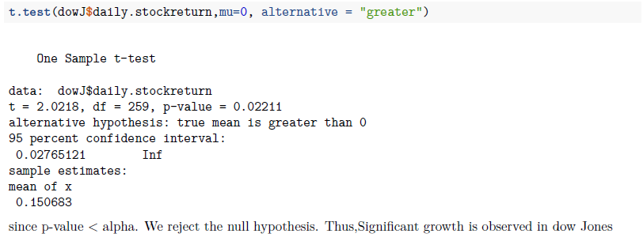

*Figure 4: T-Test for Dow Jones Data*

The complete results for all of the markets, spanning the 4 quarters and 2020 as a whole can be seen below in table 5. A red arrow indicates that the null hypothesis was accepted; red symbolizing that there was no significant. The green arrows represent the null hypothesis being rejected for the alternative; green symbolizing significant growth. An important aspect to note is that even though a quarter may have a red arrow, indicating that there was not statistically significant growth in that time frame, it does not mean that the market did not still increase. That is why it is possible that the quarterly test hypothesis can be accepted and the hypothesis for the full year can be accepted.

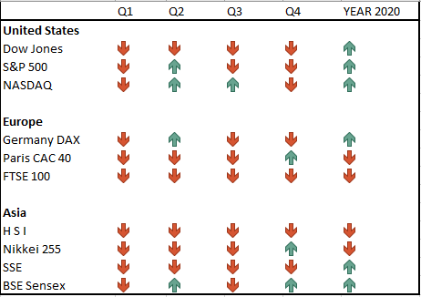

*Table 5: Results of Hypothesis Testing on a Quarterly and Annual Basis*

1. *United States state-wise scale:*

For the statewide data analysis, the correlation between the quarterly change in GDP and the infection rates for each state was not very significant. The coefficient for the correlation between the infection rates and Q1 change was *0.17* and the coefficient for Q2 was *0.25*. Neither of these coefficients of correlation are large enough to suggest that the GDP performance in a given state is directly correlated to the states infection rate. The pair matrix plot, seen in figure 5, which shows the relationship between each of the 3 factors, further supports the results that the infection rate is not directly impacting quarterly performance. Additionally, the non-linear relationship between infection rates and quarterly change is clearly illustrated in the residuals plot in figure 6. If the infection rates and quarterly change were directly related to one another, the residuals would appear uniformly distributed evenly across the plot.

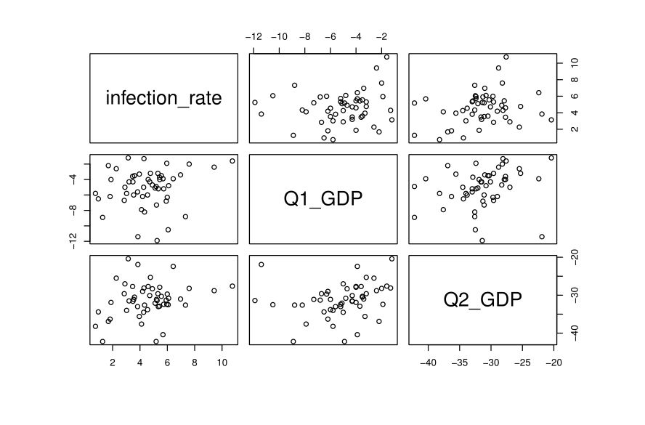

*Figure 5: Pair Matrix Plot of Infection Rates and Quarterly GDP Change*

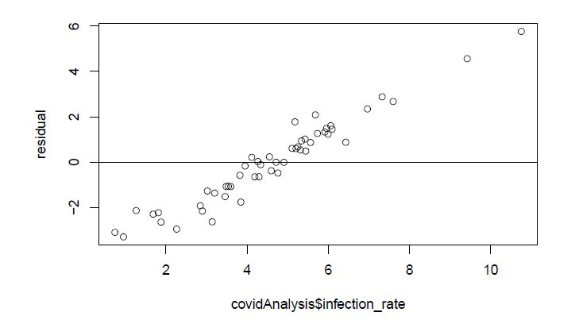

*Figure 6: Residuals Plot for Q2 GDP Change and Infection Rate*

The top 5 states with the most Coronavirus cases to date was California, Texas, Florida, Illinois, and Georgia in that order. These five states had an average second quarter GDP change of *-29.6%*. The 5 states with the least number of infections were Wyoming, Arkansas, New Hampshire, Maine, and Vermont. These states with the least amount of Coronavirus cases had an average second quarter GDP change of *-33.98%*, which is significantly greater than that of the states with the largest numbers of cases. Interestingly, the national average change in states GDP in the second quarter, as per the BEA dataset, was -*31.4%*. This means that the states with the least number of Covid-19 infections actually struggled more economically than the average state by a margin of 2.6%. Additionally, states with the most Covid-19 infections outperformed the average change in GDP by more than 1% percent on average.

|  |  |  |  |  |  |
| --- | --- | --- | --- | --- | --- |
|  | Order | State | GDP Q1 Change | GDP Q2 Change | Average Q2 Change |
| Most COVID-19 Infections | 1st | California | -4.3 | -31.5 | -29.6 |
| 2nd | Texas | -6.2 | -29 |
| 3rd | Florida | -4.3 | -30.1 |
| 4th | Illinois | -6.3 | -29.7 |
| 5th | Georgia | -4 | -27.7 |
| Least COVID-19 Infections | 46th | Wyoming | -10.5 | -32.5 | -33.98 |
| 47th | Arkansas | -4 | -27.9 |
| 48th | New Hampshire | -2.2 | -36.9 |
| 49th | Maine | -6.5 | -34.4 |
| 50th | Vermont | -5.8 | -38.2 |

*Table 6: Comparison of Quarterly GDP for States with the Most and Least Amount of Infections*

**Conclusions**

1. *Global analysis:*

The results of this study provided significant evidence to support that the null hypothesis stated earlier must be rejected. Despite the massive fall in all of the exchanges around the world and even with the ongoing pandemic, markets have proven to be resilient and have shown growth. These results are both surprising and encouraging because at the beginning of the pandemic many leaders in the industry had sounded the alarm of a potential recession.

1. *United States state-wise scale:*

The results for how the Coronavirus pandemic impacted individual states economies were mixed. The analysis shows that there was not a significant relationship between the infection rates and the quarterly changes in the GDP for each state. However, since the correlation between Q2 changes and states infection rates was slightly stronger than the correlation between Q1 changes and infection rates, it may prove insightful to extend this study to the Q3 report once it is released. If the trend continues such that the 3rd Quarter changes in GDP for each state are more closely correlated to the infection rates, a connection between a states response to the Coronavirus pandemic and its effects on their economy may be made.

The comparison between states with the largest amount and least amount of Coronavirus cases indicated that the economies of states with the lowest amounts of infections experienced a more profound shrink in their GDP then their counterparts. This could be due to many factors, one of which may be that more stringent restrictions in these states may be having a greater effect on their economic growth. However, to test this theory a deep analysis into the Covid-19 response on a state-by-state basis would need to be conducted, which is outside of the scope of this study.

**References**

1. data.cdc.gov
   * Covid-19 Data by state
2. [www.bea.gov](http://www.bea.gov)
   * Quarterly change of GDP by State
3. S&P Capital IQ Palatiform
   * Datasets on global stock markets